**TUGAS PERTEMUAN 2**

**WEB PROGRAMMING 2**



**Disusun Oleh :**

Nama : Wiwin Nur Kholifah

NIM : 18090030

Kelas : 5C

k

**DIV TEKNIK INFORMATIKA**

**POLITEKNIK HARAPAN BERSAMA TEGAL**

**2020**

* Materi

1. View-latihan2.php
2. Source Code

view-latihan2.php 🡪 application/views

1. Model1.php
2. Source Code

Model1.php 🡪 application/models

1. Latihan1.php
2. Source Code

Latihan1.php 🡪 application/controllers

1. URL

<http://localhost/web_wiwin/index.php/Latihan1/penjumlahan/5/10>

1. Capture Hasil

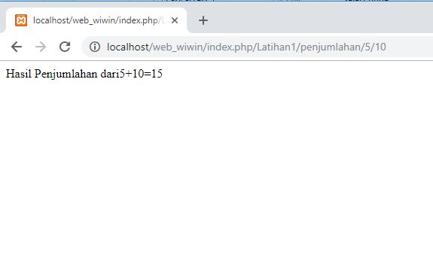

1. Latihan2.php
2. Source Code

Latihan2.php 🡪 application/controllers

1. URL

<http://localhost/web_wiwin/index.php/Latihan2/penjumlahan/5/10>

1. Capture Hasil

